AlexNet-fastRCNN Aircraft Detector Pipeline

The dataset consists of good-quality satellite imagery of airfields and terminals with passenger airplanes.

| **Total boxes** | **Mean boxes/tile** | **Max boxes/tile** | **Min boxes/tile** |
| --- | --- | --- | --- |
| 3425 | 33.25 | 92 | 5 |

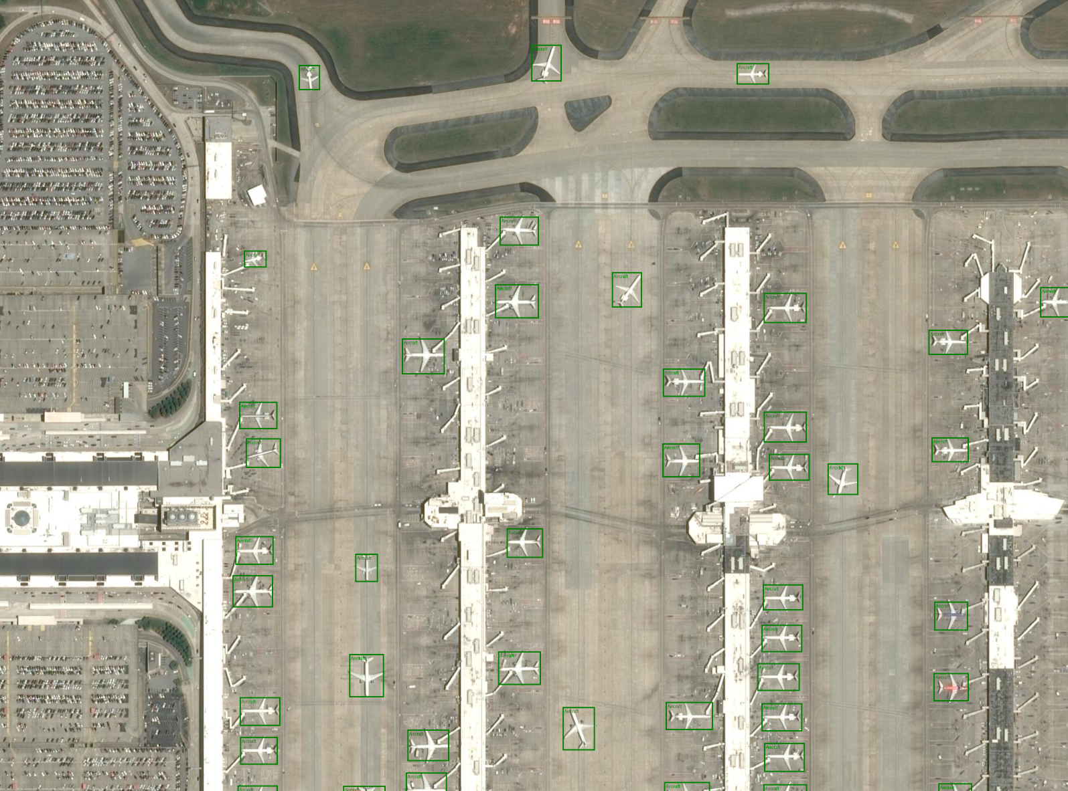

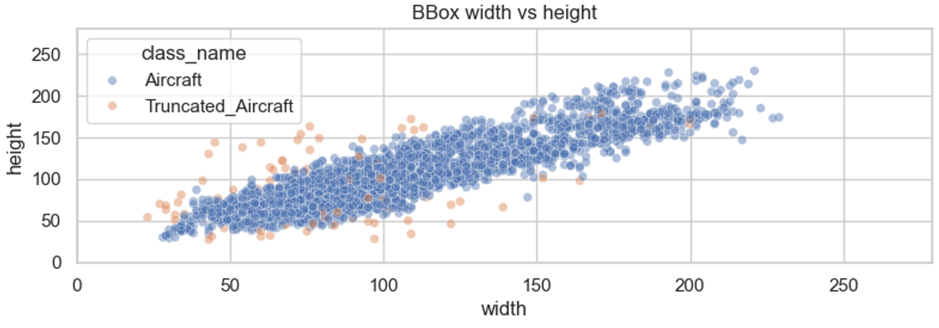

This graph shows that most of box aspect ratios are rectangular with slight deviations, so I used these values as anchor for my FastRCNN detection head: (0.5, 1.0, 1.5)

Pretrained AlexNet Classifier

My pipeline starts with a hand-built AlexNet backbone (five conv blocks mirroring the 2012 design) that feeds a Faster R-CNN detection head (RPN + ROI heads). I first pretrain the AlexNet backbone as a binary classifier on a synthetic aircraft/background dataset to give it useful low-level filters, then plug those weights into the detector and fine-tune end-to-end.

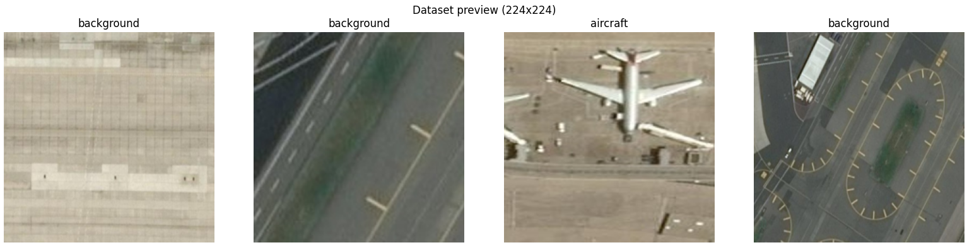

I vibe-coded creation of synthetic dataset for the purpose of training the classifier.

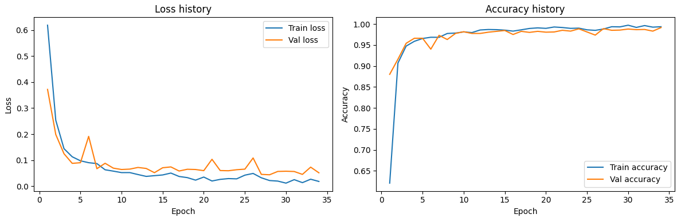

And trained the AlexNet model to predict whether there is an airplane on the image or a background.

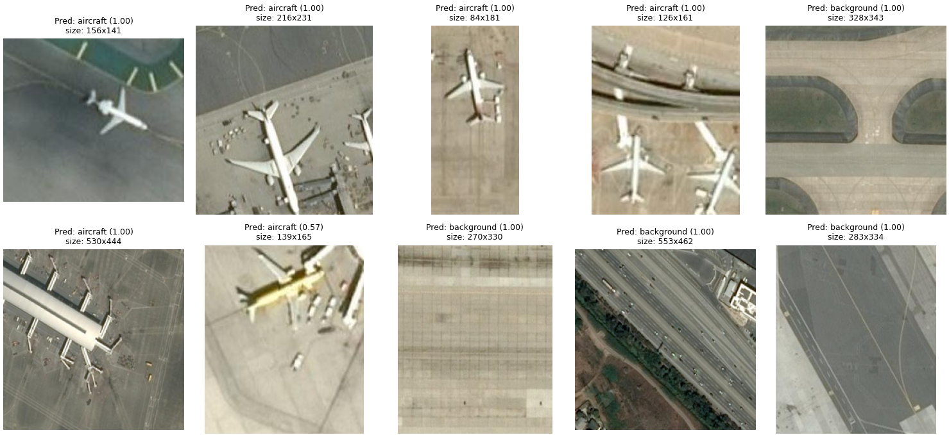

Later I realized that it was just a funny way to waste time.

Detector Training

I experiment with different numbers of unfrozen blocks in pre-trained AlexNet to test if the pretraining matters at all (trainable layers = 2, 3, 4, 5). And I was quite upset with the fact that 4 and 5 (almost full and full training of previously trained AlexNet) were giving the fastest and the best results. Training of 2 or 3 layers gave me maximum 0.1-0.17 mAP50 score, while 4 and 5 reached values 0.2 and more.

Evaluation of full object-detection network relies on COCO-style mAP@0.5 (“mAP50”) to compare trials, and Optuna logs show the metric improving alongside better hyperparameter selections. mAP50 seemed to be more intuitive way to determine how well model performs.

The loss function I used was a complex of:

* loss_classifier: cross-entropy over ROI(Region of Interest) head class logits.
* loss_box_reg: Smooth L1 regression loss for the ROI head box refinements.
* loss_objectness: binary cross-entropy for the RPN(Region Proposal Network) aircrat/background (objectness) scores.
* loss_rpn_box_reg: Smooth L1 regression loss for the RPN anchor adjustments.

I used the sum of those four terms to get the scalar loss that is logged and backpropagated.

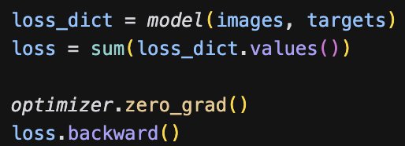

Training uses AdamW (consistently stronger than SGD here) with Optuna-tuned hyperparameters: base learning rate ≈3e-4, very small weight decay (~4e-6), plus separate multipliers for the detection head and backbone (head multiplier ~2.1, backbone ~0.2). Essentially, for parameter adjustment in RPN/ROI head the base LR was multiplied by 2-4, depending on the run, and in backbone 0.5-0.1.

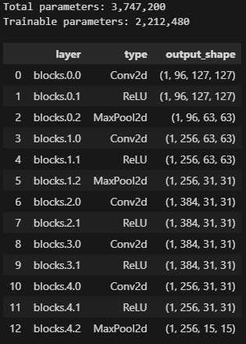

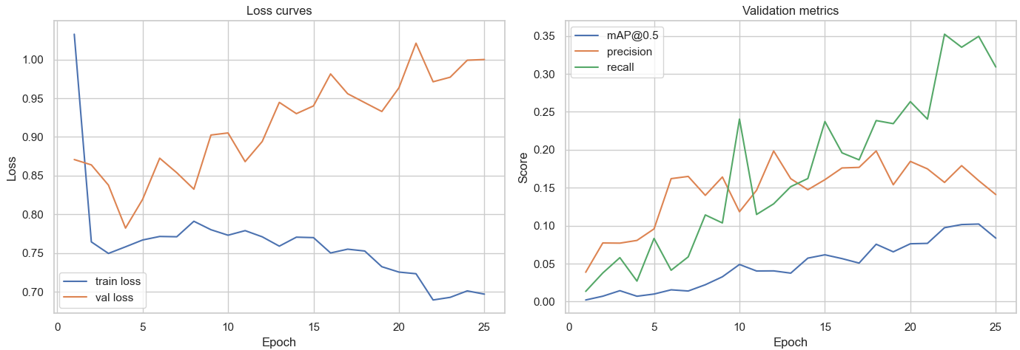

3 frozen layers

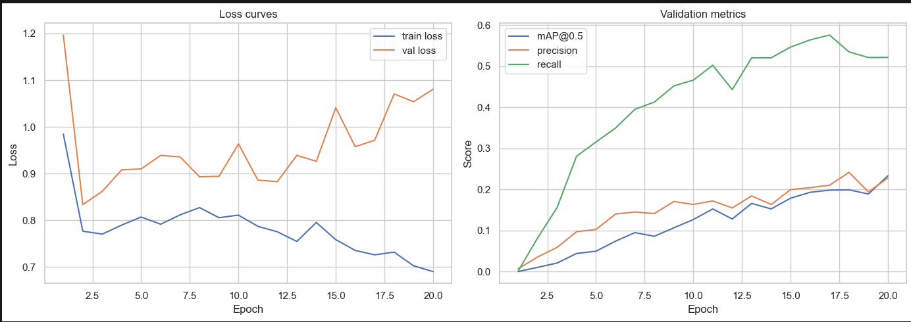

1 frozen layer

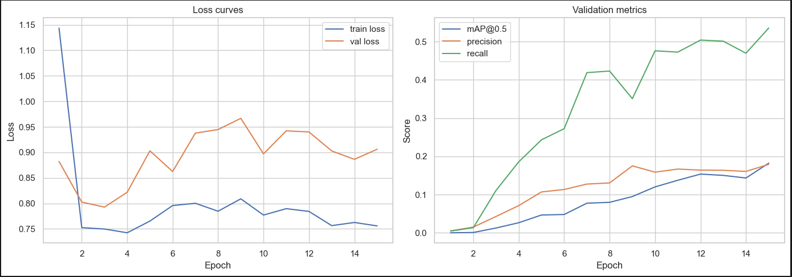

No frozen layers

Due to my previous struggles to pretrain the AlexNet with Aircraft or Background classifier, I was biased to focus on training of 4 layers with greater number of epochs (50) to attempt achieving best possible results.

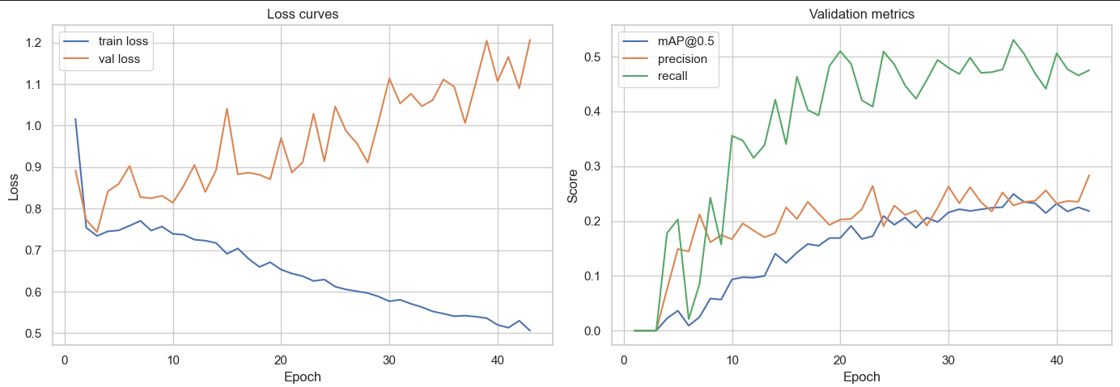

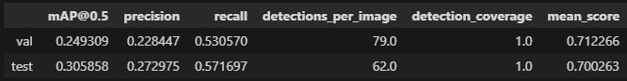

1 frozen layer, 50 epochs

